INTRODUCTION TO GREEK AND ROMAN ARCHAEOLOGY
Spring 2018
Location: AB2160 - Time: MW5

Instructor: Dr. Bice Peruzzi,
Office: 6186
Email: bice.peruzzi@classics.rutgers.edu
(expect a response within 24 hours)
Office hours: (by appointment)
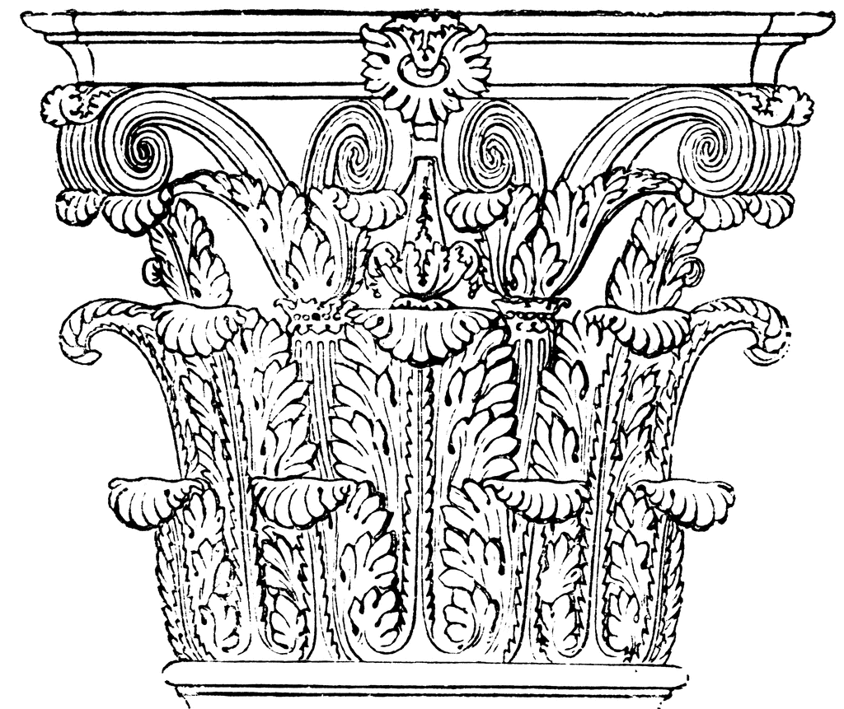

COURSE DESCRIPTION:
This course is an introductory survey of the archaeology, architecture and material culture of the Mediterranean world from the Bronze Age throughout the transformation of the Roman Empire following the reign of Constantine. While we consider chronological developments, we will also place Greek and Roman artistic production into its social and cultural settings. Along the way we will think about approaches and methodologies for the study of Classical Art, and how these may tell us more about ourselves than the ancient Greeks and Romans.

CORE LEARNING GOALS:
This course is certified for the following learning goals:
HST: Understand the bases and development of human and societal endeavors across time and place.
AHp: Analyze arts and/or literatures in themselves and in relation to specific histories, values, languages, cultures, and technologies.

COURSE LEARNING GOALS:
At the end of this course, the successful student will be able:
- To describe the main artistic contributions of the Ancient Greeks and Roman, and to explain their significance;
- To identify the broad historical periods of Ancient Greece and Rome and to place major events and artistic personalities within those periods;
- To learn about the daily lives of the ancient Greeks and Romans, including women, children, and slaves;
- To distinguish primary source evidence and secondary source and to acknowledge strengths and weaknesses in each.

CLASSICS DEPARTMENT LEARNING GOALS:
At the end of this course, the successful student will be able to:
- Demonstrate a broad knowledge of the ancient world.
- Produce culturally and historically informed analyses of Roman and ancient Greek ideas and artifacts.
- Make connections between the ancient and modern world.
- Acquire necessary analytical, research, and thinking skills to read critically.

PREREQUISITE: No prerequisites for this course and no knowledge of the ancient world is assumed. However, please realize that this course will require a lot of reading and will involve learning a lot strange names as well as specific dates.

TEXTBOOKS:
- Stansbury-O’Donnell, Mark D. A History of Greek Art. Wiley Blackwell, 2015
ISBN: 978-1-4443-5015-9 (Abbreviation Stan-O’Don)
- Fred S. Kleiner, A History of Roman Art, Enhanced Edition Wadsworth, 2010. ISBN 978-0495909873 (Abbreviation Kleiner)

Please, do not use other edition of the books as content, pagination and illustrations are different in earlier versions! Additional reading assignments are available on the course website through the Sakai homepage.
ASSESSMENT:
Grades for this class are based on a combination of group projects, tests, and other written work designed to assess your ability to discuss Greek and Roman material culture and its function and meaning in Greek and Roman society. Your final grade will be based on the following assessment:
Paper | 20%
Participation and assignments | 15%
Midterms | 30%
Final Exam | 35%

PAPER:
Each student will write a 2-3 pages paper on daily life in Pompeii (detailed guidelines will be distributed and discussed in class). This paper will be due in the last week of class, and it will be worth 20% of the final course grade.

ASSIGNMENTS AND PARTICIPATION:
Students are required to prepare material carefully for class and to engage actively with work in the classroom. Various activities, such as in-class writing, groupwork, and announced and unannounced quizzes, as well as participation contribute to this 15% of the final course grade.

MIDTERM AND FINAL EXAM:
Assessment on the content of the courses will also be done through two exams. They will be a combination of identifications and essays. Details for these major assessments (worth cumulatively 65% of the final course grade) will be provided in class. If you have any conflict, please let me know as soon as possible.
CLASS PROCEDURES AND POLICIES:
- Please respect each other and the instructor in the classroom, especially if someone is voicing an opinion different from your own.
- Readings are due on the day they are assigned, so please read the day’s assignment before coming to class. Please bring the book with the day’s assignment with you and any questions or comments you might have.
- All students are expected to attend all classes. You may find the University policy on absences and missed work, as well as a link to the self-reporting system, here: https://sims.rutgers.edu/ssra/
- Regular class attendance/participation and completion of reading is crucial to success in this class and is worth a large portion of the grade (15%). If you do need to miss a class, it is your responsibility to get notes from a friend on the material you missed.
- Please note: Failure to complete any of the major assignments will almost always result in an F.
- Late papers may be accepted with prior negotiation and with a grade penalty. If you are unable to attend an exam due to illness or emergency, it is your responsibility to get a message to me as soon as possible
- This course will use the Sakai site. I will post handouts and lecture slides, send you e-mails through the site, and you will be able to access your course grades at any time. You are responsible for receiving all e-mails I send to you, so make sure your email on Sakai is the one you check.
- I am here to help! I do realize that this course will require you to learn countless unfamiliar names and dates. If you are having troubles with anything, please come to office hours!
ACADEMIC MISCONDUCT, PLAGIARISM, AND CHEATING:
I consider academic dishonesty a waste of your potential and my time, and I do not tolerate it. So, please, do not do it. Furthermore, the university takes plagiarism very seriously. Please familiarize yourself with the university’s academic integrity and plagiarism policies so as to avoid any form of unintentional (or intentional!) academic dishonesty: http://academicintegrity.rutgers.edu/.
STUDENTS WITH DISABILITIES:
If you need academic accommodations because of a learning, physical, or other disability, please see me at the beginning of the semester.
Schedule of lectures and Readings
Class 1: Introduction to the Ancient World.
Readings: Stan-O’Don ch.1, pp. 2-17.
Class 2. The Knossos Labyrinth: Bronze Age and Minoan Civilization
Readings: Stan-O’Don pp. 21-43; 49-52.
Class 3. The real face of Agamemnon: Mycenaean Civilization.
Readings: Stan-O’Don, pp. 43-46; 52-67; Online reading: Chadwick, pp. 146-156. Photo Assignment due.
Class 4. Out of prehistory, into the (not so) Dark Ages: Greek Iron Age and the Orientalizing Period.
Readings: Stan-O’Don, pp. 70-96; 132-151.

Class 5. Sanctuaries and Architecture:
Readings: Stan-O’Don, pp. 153-178. Online reading: Antonaccio 1994, pp. 389-410.
Class 6. The March toward Naturalism: Archaic sculpture; Kouroi and Korai.
Readings Stan-O’Don, pp. 180-199.
Class 7. Pottery in the Athenian Symposion and Elsewhere.
Readings: Stan-O’Don, pp. 199-208; pp.118-122; 273-285.
Class 8. Setting the scene for Athens’ Golden Age: Olympia and Aegina.
Readings: Stan-O’Don, pp. 236-247.
Class 9. Public Spaces: Acropolis and Agora
Readings: Stan-O’Don, pp. 99-109; 246-253.
Class 10. The Athenian Acropolis and the Parthenon.
Selection of Articles available online; In Class Activity.
Class 11. The Fourth Century in Greece
Readings: Stan-O’Don, 288-318.
Class 12. Everyday life in Greece.
Readings: Stan-O’Don, pp. 320-340. Online Reading: Nevett 2010, pp. 5-10.
Class 13. The New World: Alexander and the Hellenistic Period.
Readings: Stan-O’Don, pp. 345-361.
Class 14. MIDTERM.
Class 15. Introduction to Roman Archaeology; Italy before Rome.
Readings: Kleiner, Introduction. Online Reading: Woolf 2004, pp. 417-428.
Class 16. Italy before Rome part 2: the Etruscans.
Readings: Kleiner, chapters 1 and 2.
Class 17. Roman Republic
Readings: Kleiner, chapters 3 and 4 .Online Reading: Rose: 2008, pp. 97-131.
Class 18. Augustus
Readings: Kleiner, chapter 5. Online Reading: Ulrich 2003, pp. 49-80.
Class 19. Augustus
Readings: Kleiner, chapter 5.
Class 20. The Julio-Claudian Family.
Readings: Kleiner, chapters 7 and 8.
Class 21. Savior to Despot: the Flavians.
Readings: Kleiner, chapter 9.
Class 22. Pompeii and the Bay of Naples
Readings: Kleiner, chapter 10.
Class 23. The High Empire: Trajan
Readings: Kleiner chapter 11.
Class 24. The High Empire 2: Hadrian.
Readings: Kleiner, chapters 12 and 13.
Class 25. Life and Death in Ancient Rome
Readings: Kleiner, chapters 14-15.

Class 26. The Severans; Roman North Africa,
Readings: Kleiner, Chapters 16-17; Online Reading: Taub 1993, pp. 9-19.
Class 27. The Third Century Crisis
Readings: Kleiner, chapters 18-19. Paper Due
Class 28. Constantine and Early Christian Art.
Readings: Kleiner, Chapters 19-20,

