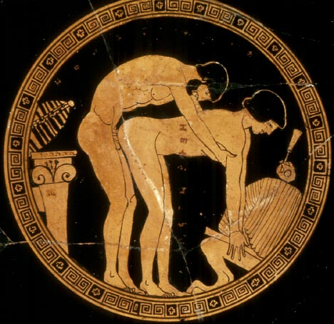
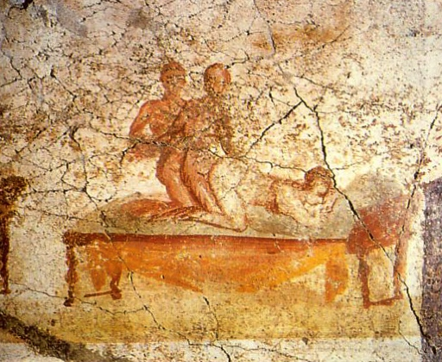
Obscenity in Greece and Rome
16:190:507 Spring 2014
Friday 1:00-3:40 pm
Ruth Adams Building 003, D/C

Leah Kronenberg Ruth Adams Bldg. 006 (DC)
Department of Classics 848-932-9600
Office Hours: Tuesday 1-2 pm (and by appt.) kronenb@rci.rutgers.edu

Course Description

What is obscenity? Is it a relative, cultural concept or is there anything universal about what human beings deem obscene? How did the Greeks and Romans define obscenity? What aspects of Greek and Roman culture have later centuries considered obscene and how have they dealt with those obscene aspects? Are there areas of overlap between modern concepts of obscenity and ancient Greek and Roman ones? How does obscenity function in art (whether visual or verbal)? How did Greek and Roman culture contain the dispersal of obscene material? How does ours? Are there particular ancient genres or modes of art in which obscenity is permitted or “at home”? Are the artists who utilize obscenity perverted themselves or can we draw a distinction between the artist and the art? These are just a few of the many questions we will be attempting to answer this term through the examination of obscenity in ancient Greek and Roman culture. The exact topics we cover will be determined by student interest/presentations, but I include below a list of potential topics, which is roughly chronological (and by no means comprehensive):

obscenity in cults
music and obscenity
magic and obscenity
Iambic Sappho/Alcaeus
Archilochus and Hipponax
Sophron and Herodas
Aristophanes and Old Comedy
Cynics and obscenity
vase painting
Hellenistic Epigram
fescinnine verses and religious ritual
Plautus
Lucilius
Catullus and Neoterics,
Lucretius (body violation; book 4)
Laberius and mime
Cicero’s invective
Cicero’s Letter to Paetus (ad fam 9.22)
Horace’s Epodes and Satires
Priapea
Catalepton
Ovid’s Ars Amatoria
Ovid’s defense of his erotic poetry in his exile works
sex manuals
graffiti
erotic/obscene wall paintings from Pompeii (and other Roman art)
Petronius
Persius and Juvenal
Martial
later Greek epigram (Lucilius, Nicarchus, Strato)
Suetonius on the sex lives of the emperors
Ausonius
reception of obscene texts and art

Course Learning Goals

- Learn more about Greek and Roman cultural norms by examining what these cultures found repulsive and transgressive of those norms (and think about the differences from our own cultural norms)
- Learn more about the reception of Classical culture and texts
- Broaden your knowledge of Greek and Latin literature by reading texts sometimes deemed “too dirty” for the classroom
- Gain familiarity with secondary literature on the obscene
- Gain practice with research, presentation, and paper writing skills
- Learn about your fellow graduate students’ research interests

Course Website

The course website is accessible through the Sakai homepage. Go to https://sakai.rutgers.edu and follow the instructions for logging in as a student.

Texts

There are no required textbooks, and readings assigned for the course will be made available on our sakai website.

Recommended books:

Henderson, Jeffrey. 1991. The Maculate Muse: Obscene Language in Attic Comedy. 2nd ed. Oxford.

Richlin, Amy. 1983. The Garden of Priapus: Sexuality and Aggression in Roman Humor. Yale.

Richlin, Amy, ed. 1992. Pornography and Representation in Greece & Rome. Oxford.

Forthcoming (October 25, 2015):

Dutsch, Dorota and Ann Suter, eds. 2015. Ancient Obscenities: Their Nature and Use in the Ancient Greek and Roman Worlds. Michigan.

Grading and Evaluation

1. Class participation 20%
2. Presentation 30%
3. Paper 50%

Presentation Schedule (DRAFT)

 | Date | Topic/Presenters | Reading
Week 1 | Fri Sept 4 | Introduction
Week 2 | Fri Sept 11 | *What is Obscenity? Ancient and Modern answers (Class discussion)  *Aaron H.: RTI photography demonstration and research in Athens | 1) Kieran, “On Obscenity: The Thrill and Repulsion of the Morally Prohibited”  2) Henderson, “Obscene Language and the Development of Attic Comedy,” from Maculate Muse  3) Richlin, “Roman Concepts of Obscenity,” from The Garden of Priapus
Week 3 | Fri Sept 18 | *Dave: Iambic Sappho (and Alcaeus)
Week 4 | Fri Sept 25 | *Scott: Archilochus and Hipponax
Week 5 | Fri Oct 2 | *Rick: Sophron and Herodas
Week 6 | Fri Oct 9 | *Ella: Magic and obscenity
Week 7 | Fri Oct 16 | *Emmanuel: Greek vases  *Aaron B.-S.
Week 8 | Fri Oct 23 | *Alicia
Week 9 | Fri Oct 30 | *Steve
Week 10 | Fri Nov 6 | *Brian H.: Lucretius and the gruesome body
Week 11 | Fri Nov 13 | *Nicole: Invective against women  *Brian M.: Invective in Sallust
Week 12 | Fri Nov 20 | *Isaiah: Petronius
Week 13 | Fri Dec 4 | *Lyndy: Catalepton and Priapea

